Eritrea is a small low income country off the coast of eastern Africa. Numerous natural disasters and recurrent border wars have altered their development and long term sustainability (Ravinder, 2009). In fact, out of the 17 Sustainable Development Goals (SDGs), developed by the United Nations for global prosperity by 2030, Eritrea is only on track to successfully reach two. Eritrea is currently meeting and on track to reach SDGs 12 and 13, Responsible Consumption and Production, and Climate Action (Sustainable development report, 2022). This is most likely due to the lack of infrastructure in the country, as they are not putting off large amounts of pollution and over consuming general goods. The low consumption rates of Eritrea also affects trash pollution and recycling, lower income countries tend to have a lower turnover with frivolous items resulting in reduced ground pollution. Eritrea also has a low death rate due to outdoor ozone pollution of only 2 per 100,000 deaths, indicating and further highlighting their lack of pollution from the general population(SDG Tracker, 2022).
However, although ozone and global pollution may not be an issue for Eritrea, localized pollution and inhalation hazards remain a significant concern. As the household ambient air pollution deaths are still very high (240 per 100,000) this indicates either a lack of knowledge or more likely, better technology for transportation and cooking. As seen in class through a guest speaker, often in places where there are no other options than coal and wood burning stoves, there is cooking with little to no air filtration and movement, making the number of lung issues, diseases, infections, abnormally high. This correlates with the number of deaths specifically to household air pollution, 194 per 100,000 people (SDG Tracker, 2022).
Similarly related, 9 other SDGs including clean water and sanitation (#7) and quality education (#4) appear to be seemingly unachievable with significant challenges remaining by 2030 (Sustainable development report, 2022). As mentioned earlier, the lack of technology and infrastructure due to recurrent wars and natural disasters plays a large part in the achievement of SDGs but also in the general well being of a country. Constant fluctuation in political systems creates instability within hospitals, educational systems, and other government funded systems. Although corruption has declined in recent years, in the past, this could have affected the distribution of funding, as well as the development of educational systems. As far as clean water and sanitation, the correlation of improper sanitation and low income countries is all too common, and can be due to a plethora of causes including but not limited to access/inadequation resources, improper funding, lack of education, rurality lack of support from governmental or NGOs, and of course simply but not so simply poverty. I believe that all of these contribute to Eritrea’s failing of these SDGs and that there is no simple solution, other than continued global support in long term nationwide sustainability and development.
However as mentioned in class, all SDGs lead back to SDG 3. Without successful work towards the other goals SDG 3 is not obtainable. This is a continued project in Eritrea that has multiple areas surrounding continued health and well being specifically that need work, but also as a country that has many other SDGs “in progress” their work affects the outcome of SDG 3 as well.
As mentioned earlier, clean water and sanitation remains to be a goal that faces significant challenges if completed by 2030, this too, has direct correlation with SDG 3, Good Health and Wellbeing. In regards to target 6.1 to achieve universal and equitable access to safe and affordable drinking water for all, Eritrea faces a mortality rate of 66.3 deaths per 100,000 people due to unsafe water and hygiene (SDG Tracker 2022). This may be due to the lack of safe water services, one that is indicated and can be categorized in 6.1.1 as the proportion of population using safely managed drinking water services. This goal and target work in coordination with target 3.9 to substantially reduce the number of deaths and illnesses from hazardous chemicals and air, water and soil pollution and contamination. This is indicated, similar to the mortality rate by categorizing the mortality rate as attributed to unsafe water, unsafe sanitation and lack of hygiene (exposure to unsafe Water, Sanitation and Hygiene for All (WASH) services) (The United Nations 2022). One way to tackle some of these health issues is isolated in a different target of goal 3, target 3.c to substantially increase health financing and the recruitment, development, training and retention of the health workforce in developing countries, especially in least developed countries and small island developing States, indicated by Health worker density and distribution (The United Nations 2022). A lot of these goals and targets align, and understanding the relationships between the goals can allow efforts to be coordinated so again, long term sustainability can be achieved.
However, despite many of the challenges that Eritrea faces, in some areas there have been significant progress made in attempt to achieve these goals, Eritrea specifically, has a rather low infant mortality rate in relation to many of the other surrounding african countries, a challenge that is specifically cited in target 3.2 with indicators 3.2.1 and 3.2.2 identifying both neonatal and under 5, mortality rates as a global concern. Target 3.b.1 also identifies a strength of Eritrea’s health care, as the proportion of the target population covered by all vaccines included in their national programme. Consistently across all of the vaccines listed, Eritrea has had over 95% of their reported population vaccinated, a global goal targeted in 3.b. Both of these strengths, indicated by targets and indicators, accentuate that since becoming independent, Eritrea has taken significant steps in increasing health prevention and care in the country, one that sees specific outcomes due to the initiatives. This is most likely due to the start work of implementing basic health care coverage and programs (The World Bank, 2004).
Although Eritrea is behind many countries in their process of SDGs, it is not a race and they are actively making efforts to improve the lives of their citizens. It is expected that they will meet some but not nearly all of the SDGs, given the few years left until 2030.

The SDG progress of Eritrea

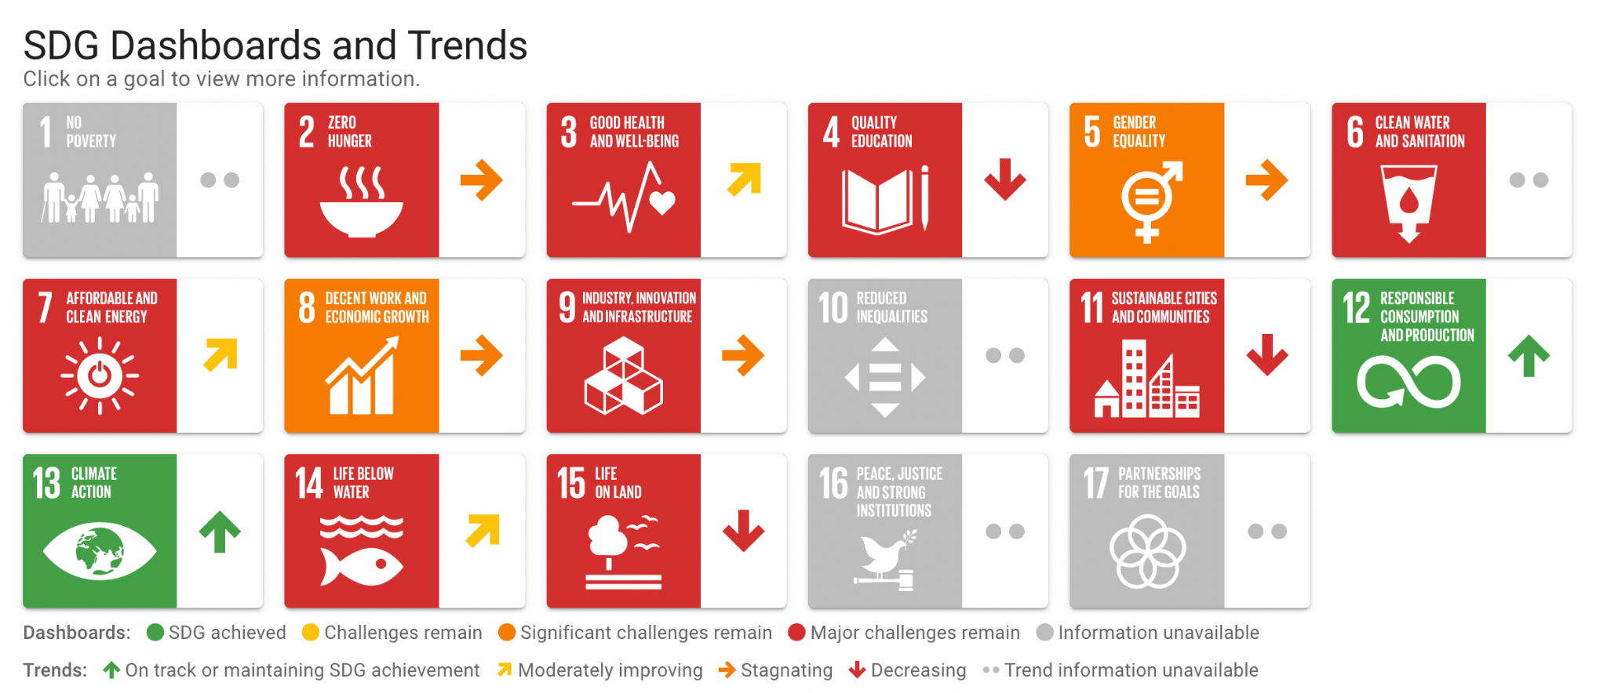

References:

Ravinder, R. (2009). Poverty in Eritrea: challenges and implications for development. National Library of Medicine. https://pubmed.ncbi.nlm.nih.gov/20726134/

SDG Tracker (2022). Sustainable Development Goals/Good Health and Well-Being. SDG Tracker. https://sdg-tracker.org/good-health#targets

Sustainable development report. (2022). Eritrea Sub Saharan Africa. Sustainable development report. https://dashboards.sdgindex.org/profiles/eritrea

The World bank. (2004). The Health Sector in Eritrea. A World Bank Country Study. https://documents1.worldbank.org/curated/en/461991468770937666/pdf/297930PAPER000182131587616.pdf

United Nations. (2022). Goal 3 Ensure Healthy Lives and Promote Wellbeing for All at All Ages. United Nations. https://sdgs.un.org/goals/goal3

