Descriptive Epidemiology Report: COVID-19

Description of COVID-19
COVID-19 is an infectious lung disease caused by the SARS-CoV-2 virus. This virus is a member of the common coronavirus family that causes infections in the sinuses, nose, and throat and spreads via respiratory droplets (WebMD, 2021). Although about 30% of COVID-19-infected individuals appear asymptomatic (HHC, 2021), the remaining 70% will show some form of symptoms, with 1 in 6 infected individuals suffering from severe COVID-19 symptoms (WebMD, 2021). Reported symptoms of COVID-19 include: fever or chills, fatigue, body aches, headaches, loss of taste and/or smell, nausea, diarrhea, and congestion. However, as COVID-19 is a lung disease, the most common symptoms include: coughing, sore throat, and shortness of breath(ALA, 2021). Although those with mild symptoms (80% of people that contract this disease) are released from quarantine and expected to recover without serious medical treatment within 14 days, those with more severe COVID-19 symptoms may contract severe respiratory issues and long term side effects (WHO, 2020).
The COVID-19 pandemic has cost nearly 2.5 million lives and affected daily living worldly from 2019-2021. This virus is recognized as a current global pandemic and serious health concern to those with underlying health conditions and eldelry beings. As this is not an isolated, but global issue, examining distribution patterns of COVID-19 as well as its development may allow for a better understanding of the current pandemic, as well as how to prepare for future outbreaks.

Distribution
Since December 31, 2019, there have been approximately 109,206,497 cases of COVID-19 and 2,407,469 deaths worldwide (ECDC, 2021). In the United States, there is an average infection rate of 29,650 cases of COVID-19 per one million people, with 719 of those cases resulting in death. Globally there is an average of 6,260 cases per one million people with an average of 158 of those cases resulting in death (CDC, 2020). The United States has a slightly lower mortality rate of 0.024% compared to the global average mortality rate of 0.025% (CDC, 2020). However, the United states has a larger morbidity rate of 0.0002965% , compared to the global rate of 0.0000626% (CDC, 2020).
Globally, the COVID-19 case-fatality rates are higher for men than women. In most countries that have provided data, the male to female case fatality ratio is higher than 1:0 (Dehinga and Raj, 2021). Although the number of women that have contracted COVID-19 is higher than men (51.7% of women to 48.3% of men), more men have died of COVID-19 (54%of men to 46% of women). This data infers that men have a higher risk of severe symptoms and death when contracting COVID-19 (CDC, 2020).
Another factor that correlates with the mortality rates of COVID-19 is race. In the US, Indiginous Americans, Black Americans, and Pacific Islanders have the highest mortality rates from COVID-19. White and Asian Americans have the lowest age-adjusted mortality rates (APM Research Lab, 2021).
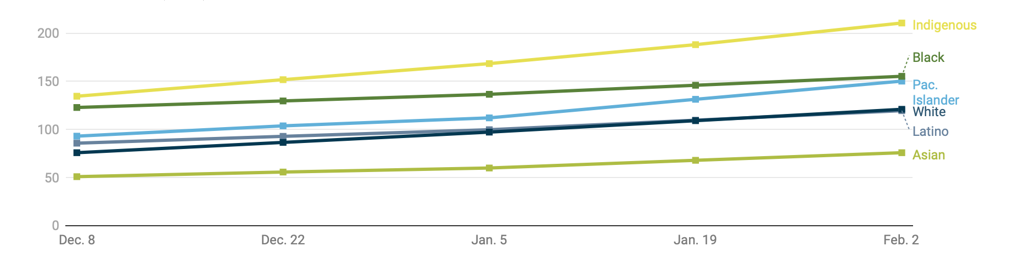
Figure 1. Cumulative Actual (crude) COVID-19 Mortality Rates per 100,000 by Race and Ethnicity (APM Research Lab, 2021).

COVID-19 has shown severe symptoms and deaths in white non-Hispanic males and elderly (85+) individuals. The risk of death from COVID-19 increases exponentially as age increases. People who are 85 or older are 7900 times more likely to die from COVID-19 and 80 times more likely to be hospitalized than the reference group of 5-17 year olds, even though they only have 2 times the cases in comparison (CDC, 2021).
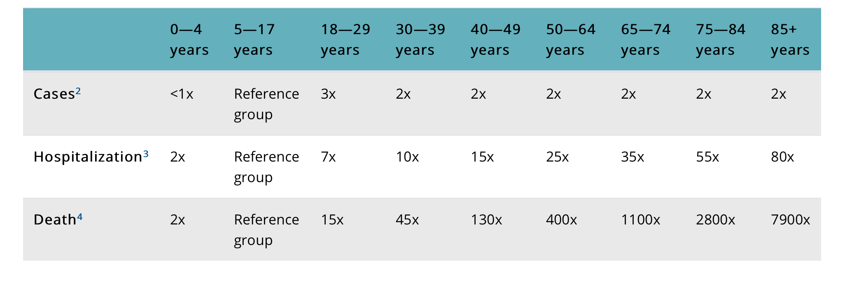
Figure 2. Rate Ratios Compared to 5-19 Year Olds (CDC, 2021).

Additionally, individuals with underlying or chronic medical issues such as high blood pressure, diabetes, heart problems, lung issues, etc. are also at high risk for developing more severe symptoms of COVID-19 (WHO, 2020). It is important that people with these risk factors take extra precautions to avoid COVID-19 since they have an increased risk of hospitalization and implications.
Environmental factors play a role in the spread of the coronavirus. Geographically, COVID-19 has an effect worldwide. The virus originated in Wuhan, China and has since spread to every continent except for Antarctica (McIntosh, 2021). Currently, North America, South America, and Europe are experiencing the highest numbers of reported cases.
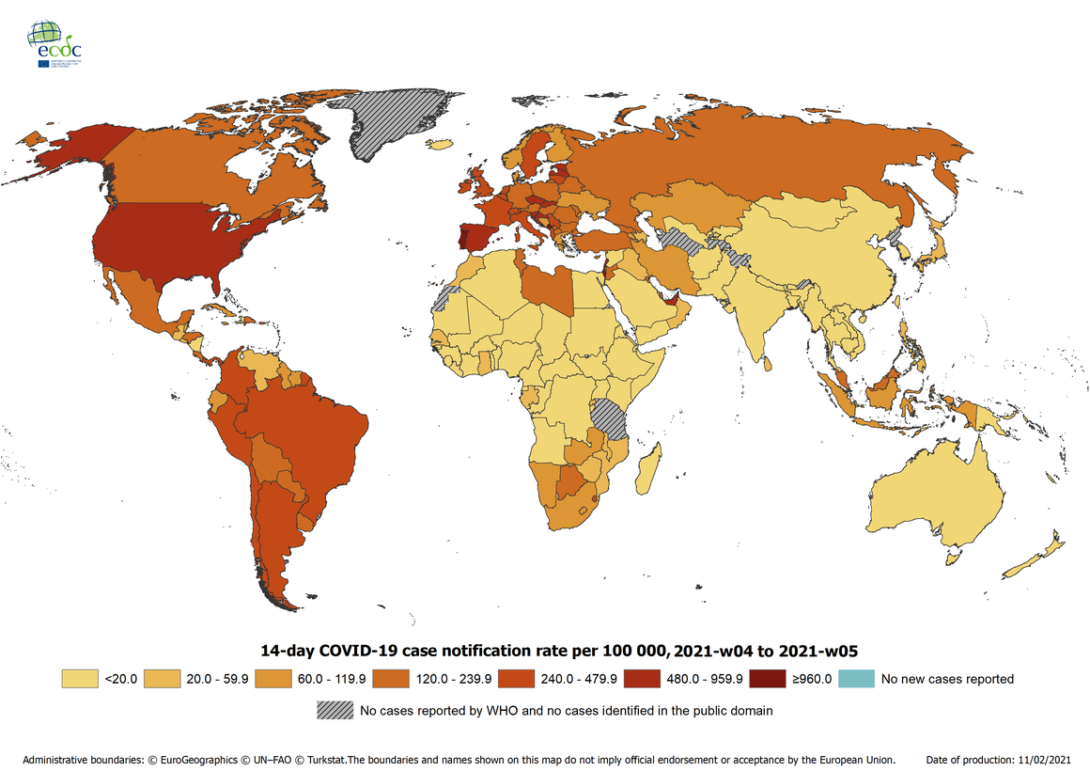
Figure 3. 14-day COVID-19 Case Notification Rate per 100,000 (The Conversation, 2020)
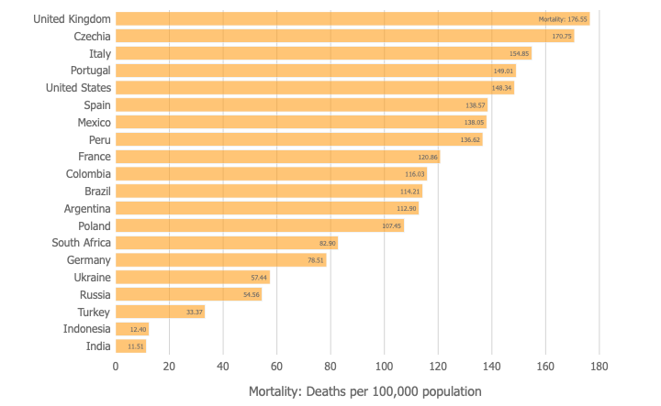
When comparing the case rates and mortality rates worldwide, it is clear that in some countries the case rates did not always correlate with mortality rates. For example, the United States has had 86,577 cases per million population while the United Kingdom has had 60,420 cases per million population (Elflein, 2021). Despite a lower case rate in the UK, their mortality rate is 176.55 per 100,000 people, while the US has a mortality rate of 148.34 (Johns Hopkins University & Medicine, 2021). This portrays that there are other factors affecting the course of disease and people in different countries may have varying rates of incidence and mortality.
Figure 4. Mortality Rates Internationally per 100,000 Population, (Johns Hopkins University & Medicine, 2021).
Socioeconomic factors are environmental attributes that have proven that different groups are facing different levels of risk when it comes to COVID-19. According to research by Patel et. al, people of lower socioeconomic status are more likely to be exposed to the coronavirus because of over-crowded accommodations, fewer opportunities to work from home, and increased stress due to financial uncertainty caused by the pandemic (Patel et. al., 2020). Additionally, poverty is a risk factor for hypertension and diabetes, which are risk factors for COVID-19. This has resulted in an increased vulnerability to COVID-19 for people of lower socioeconomic status.
Researchers are concerned that COVID-19 may be a seasonal disease, like Influenza. Many coronaviruses circulate more in the fall and winter, and research points to COVID-19 acting in the same way. Experts have found a strong correlation with latitude and temperature, causing them to postulate that COVID-19 may come in waves during the colder months after vaccinations are well established (Preidt, 2021).

Summation
The severity of the infectivity of COVID-19 has led to classification of it as a global pandemic. Although the coronavirus family has been noticed for many years, primarily in animals, the SARS-CoV-2 virus is known to cause more severe symptoms in humans such as MERS and SARS. Annexing to the increased number of cases and deaths from COVID-19, the pandemic has also affected the overall healthcare system, economy, social, and spiritual life.
The largest barrier facing the COVID-19 pandemic, is the large amounts of contradicting information and misinformation being disseminated through the media. This proliferation of non-thoroughly researched information as it undermines health officials and organizations and is especially harmful during the time of a pandemic (Lancet, 2020). There are still many unknowns surrounding COVID-19. Experts in the medical field are still unsure exactly what the long term health effects related to this coronavirus are going to be. They also do not know if COVID-19 will return every year in a temporal manner like the flu. Future epidemiologic research can be done in this area to determine how the coronavirus will impact long-term well being and whether or not it will be a recurring problem that must be dealt with each year. Besides the questions about the health-related effects of the coronavirus, there has already been a large societal shift in terms of living during a pandemic. People have become accustomed to wearing masks in public, working from home rather than commuting, and limiting interpersonal interactions. After the coronavirus is under control, it is unknown how many of these behaviors will still have a lasting impact on how we function in everyday life.
Although vaccines against COVID-19 have been initially deployed, they are currently being limited to first responders and 65+ year-olds in countries that can afford the vaccine. Even in countries that can afford the millions of vaccines required to vaccinate their growing populations, such as the United States, they are struggling to retain resources to effectively and efficiently distribute the vaccines among the population. This has led to a congestion of distribution and in the case of Florida, less than a quarter of delivered vaccines are being used, despite the vaccine being approved for over two months (NYT, 2021). As vaccines have yet to be widely distributed, it is just as important as ever to be proactive and follow guidelines that slow the spread of the disease. Some behaviors that have been scientifically proven to prevent transfer of COVID-19 are wearing a mask, maintaining six feet of distance between other people, staying home when feeling ill, refraining from touching the face, washing hands, and disinfecting surfaces (Harvard Health Publishing, 2021).

References:

American Lung Association. (2021). Coronavirus Disease (COVID-19). https://www.lung.org/lung-health-diseases/lung-disease-lookup/covid-19

APM Research Lab Staff. (2021, February 4). The Color of Coronavirus: COVID-19 Deaths by Race and Ethnicity in the U.S. APM Research Lab. https://www.apmresearchlab.org/covid/deat hs-by-race.
Centers for Disease Control and Prevention. (2020). CDC COVID Data Tracker. https://covid.cdc.gov/covid-data-tracker/
Centers for Disease Control and Prevention. (2021). Risk for COVID-19 Infection, Hospitalization, and Death By Age Group. https://www.cdc.gov/coronavirus/2019-ncov/covid- data/investigations-di scovery/hospitalization-death-by-age.html.
Dehingia, N., & Raj, A. (2021). Sex differences in COVID-19 case fatality: do we know enough? The Lancet, 9(1), E14–E15. https://doi.org/https://doi.org/10.1016/S2214-109X( 20)30464-2
Editorial. (2020). “The COVID-19 Infodemic.” The Lancet Infectious Diseases. www.thelancet.com/journals/laninf/article/PIIS1473-3099(20)30565-X/fulltext?dgcid=raven_jbs_etoc_email#%20.
Elflein, J. (2021, February 22). Case rate for COVID-19 most impacted countries worldwide 2021. Statista. https://www.statista.com/statistics/1174594/covid19-case-rate-select-countries- worldwide/.
European Center for Disease Control and Prevention. (2021, February 19). COVID-19 situation update worldwide, as of week 6, updated 18 February 2021. https://www.ecdc.europa.eu/en/ge ographical-distribution-2019-ncov-cases
Hartford Health Care. (2021). 30 Percent of People With COVID-19 Show No Symptoms: Here’s Where They Carry It. https://hartfordhealthcare.org/about-us/news-press/news-detail?articleId=29806&publicid=743
Harvard Health Publishing. (2021, February 12). Preventing the spread of the coronavirus. Harvard Health. https://www.health.harvard.edu/diseases-and-conditions/preventing-the-spread -of-the-coronavirus.
Henderson, H. (2020). From the COVID-19 epicentre: lessons from Latin American cities’ successes and failures. The Conversation.
https://theconversation.com/from-the-covid-19-epicentre-lessons-from-latin-american-cities-successes-and-failures-144000
Johns Hopkins University & Medicine. Mortality Analyses. Johns Hopkins Coronavirus Resource Center. https://coronavirus.jhu.edu/data/mortality.
McIntosh, K. (2021, February 18). Coronavirus disease 2019 (COVID-19): Epidemiology, virology, and prevention. UpToDate. https://www.uptodate.com/contents/coronavirus-disease-2 019-covid-19-epidemiology-virology-and-prevention
Patel, J. A. et al. (2020). Poverty, inequality and COVID-19: the forgotten vulnerable. Public health, 183, 110–111. https://doi.org/10.1016/j.puhe.2020.05.006
Preidt, R. (2021, February 2). Like Flu, COVID-19 May Turn Out to Be Seasonal. WebMD. https://www.webmd.com/lung/news/20210202/like-flu-covid-19-may-turn-out-to-be-seasonal
Robbins, R, et al. (2021). Here’s Why Distribution of the Vaccine Is Taking Longer Than Expected. New York Times. https://www.nytimes.com/2020/12/31/health/vaccine-distribution-delays.html
WebMD. (2021). Coronavirus and COVID-19: What You Should Know. https://www.webmd.com/lung/coronavirus#:~:text=COVID%2D19%20is%20a,to%2Dperson%20contact
WebMD. (2021). Symptoms of Coronavirus. https://www.webmd.com/lung/covid-19-symptoms#1
World Health Organization. (2020, April 17th). Q&A On Coronaviruses (COVID-19). www.who.int/emergencies/diseases/novel-coronavirus-2019/question-and-answers-hub/q-a-detail/q-a-coronaviruses

